1. Computation of Angles, Intersection, Planes, Normals to Planes, and Pitch Angles
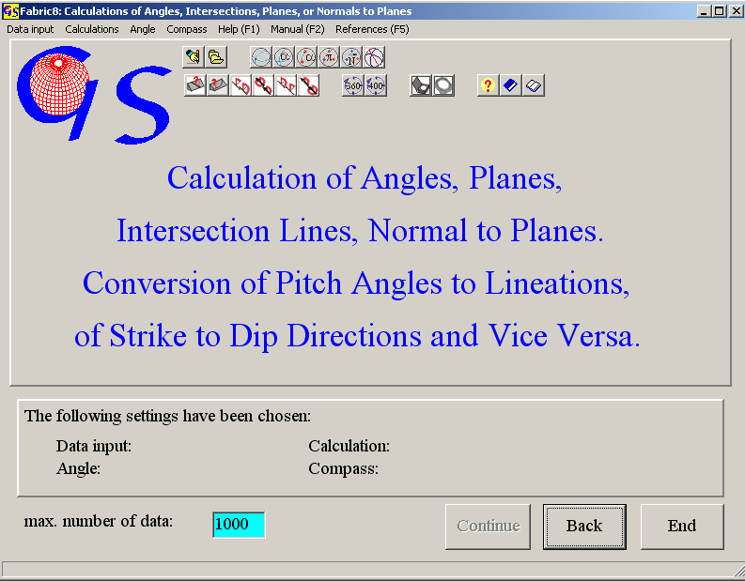
Fig.1

The first page of the program 1 is shown in Fig. 1. The program carries out the calculation of the following elements:

The intersection line of two planes 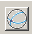,
the angle between two planes ,
the angle between two lineations ,
a plane from two lineations ,
the normal on two lineations ,
the symmetry plane between two planes
the pitch angle from a plane and a lination in it ,
a lineation in a plane from the pitch angle .
azimuth of dip of a plane to strike

azimuth of dip of a lineation to strike
strike of a plane to azimuth of dip
strike of a lineation to azimuth of plunge

At the beginning the button "Continue" is inactive, because the program expects information about the type of input (Fig. 2), the type of calculation (Fig. 3), and for manual input the scale of the compass (0 to 360° or 0 to 400°, Fig. 4), and the type of Compass (Clar- Compass for measures as azimuth of dip and angle of dip or Brunton compass for measures as strike, dip angle, and direction of dip, Fig. 5).

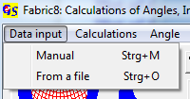 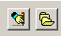 Fig. 2

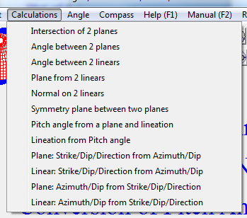
Fig. 3

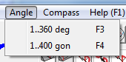
Fig. 4

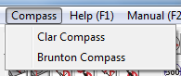
Fig. 5

The options which are clicked on are shown on the panel at the bottom of the form (Fig. 6)

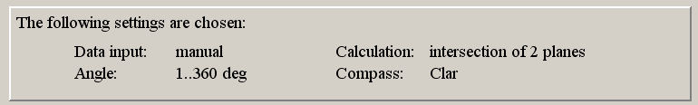
Fig. 6

When all options are clicked, the button "Continue" becomes active . Clicking on it brings you to the next form, either to manual input or input from a data file.

1) Manual Data Input:

Fig. 7 shows the form for manual input of data measured with the Clar compass and for the calculation of the intersection line between two planes. After clicking on "Start". Azimuth of dip and angle of dip must be typed, each followed by "Enter". After the input of the four angles the calculations starts. The data and the calculated values appear in the list (Fig. 7).

Fig. 8 shows the form for manual input of data, measured with a Brunton compass. The angle of strike, angle of dip, and direction of dip – North (n) or South (s) – must be typed.

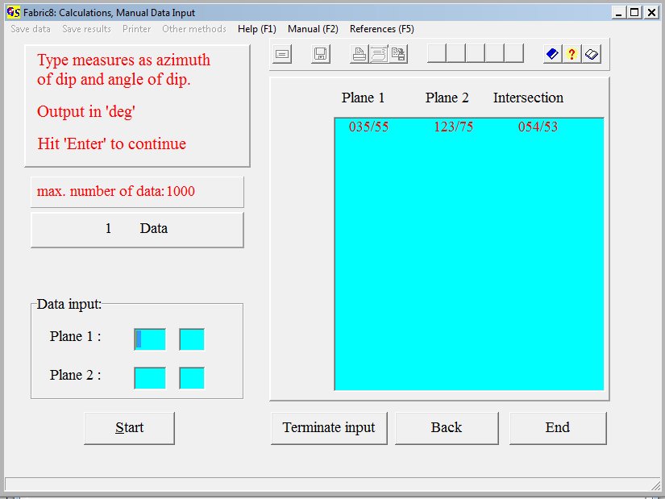
Fig. 7

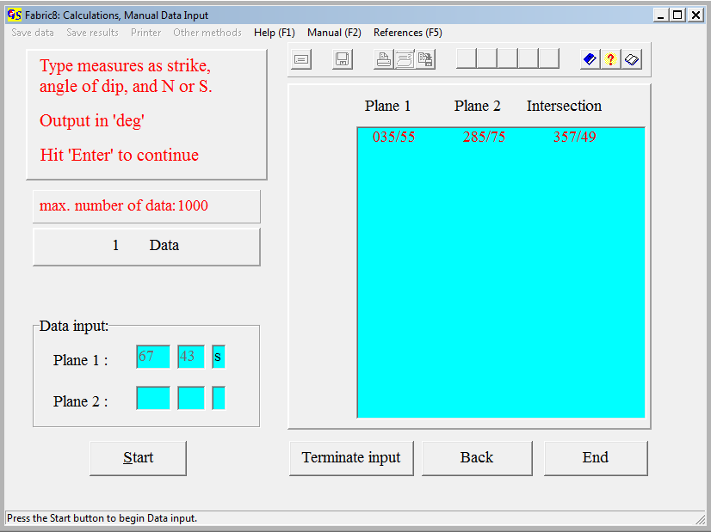
Fig. 8

For calulation of the pitch angle from a plane and a lineation, or for calculation of a lineation on a plane from a pitch angle you have to indicate whether the angle is measured clockwise or counter clockwise (Fig. 9 and 10).

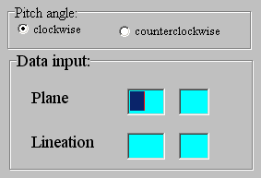 Fig. 9

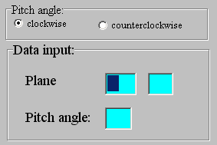 Fig. 10

Note that all data are transformed to the format ‘dip direction / dip angle’ after calculation.

After input of all data click on "Terminate input". The message in Fig. 11 appears.
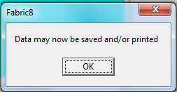 Fig.11

Now data and results may be saved and/or printed, or written to an *.rtf-file. (Fig. 12 – 14).

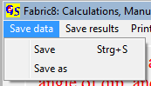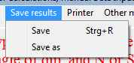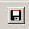
Fig. 12 Fig. 13

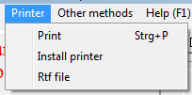
Fig.14

Saving of data and results is done as in all other Windows programs.

With the Menu " Other Methods" (Fig. 15) you can jump to the Programs 3, 4, 9, 10, or 11 to plot the data or great circles, to plot contoured diagrams, calculate statistic parameters, or to find submaxima.

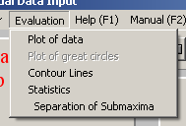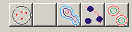
Fig. 15

If the results of the calculations are planes, the result-file gets the extension “.PLA”. For lineations the extension is “.LIN”. If the results are angles, the extension is “ANG”. These extensions are appended automatically. That means that you must type only the name of the file, without extension.
In case of the calculation of pitch angles, the input data (planes and lienations on these planes) are saved with the extension *.PLI. In case of the calculation of lineations from pitch angles on planes, the input data are saved with the extension *.PCH.

2) Data Input from a File:
In general, the form for data input from a file is the same in all programs. The form shows three list-fields. On the left a list of all data files which have the same extension appears for the path which is saved in “Fabric7.ini”. If *No file found* appears, click on “Find data Path” fo find the path for the data folder.
By clicking on an arbitrary number of file names you choose the data which you want to process. The file names are erased in the left field and appear in the middle field. Clicking on a name in the middle field cancels the choice. The cancelled names reappear again in the left field. Clicking on the button “Calculations" starts the procession, and the results are shown in the right field (Fig.14), in addition the menus “Save results”, “Save data”, and “Printer” become active. Instead of printing, data and result can be written into an *.rft-file (Fig.15).
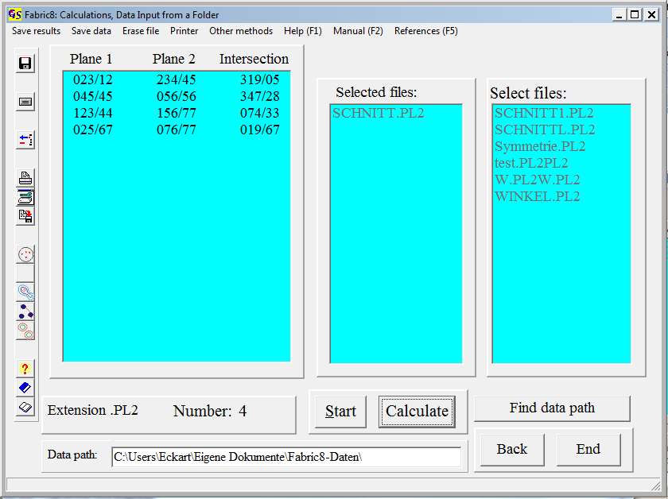
Fig.14

Intersection of Two Planes
Day of calculation: Sunday, 30.April 2006 11.12 h
Filename : SCHNITT.PL2
4 Data
1. Plane: 2. Plane: Intersection:
023/12 234/45 319/05
045/45 056/56 347/28
123/44 156/77 074/33
025/67 076/77 019/67
Fig. 15

The menu "Evaluation" was explained with manual input.

3.1 Calculation of the Intersection Line between Two Planes
This part of the program can be used to calculate a lineation as intersection of two planes (i. e. a δ−lineation from bedding and schistosity). The intersection is calculated from the cross product of the two normals to the planes (WALLBRECHER, 1986:22f.). The calculated lineations are given back as azimuth of dip and angle of dip in a 0-360°-scale. Clicking on “Print“ produces a printout of filename, day and time of calculation and a list of data and results. The found lineations can be saved in a file. The extension for the file is “.LIN“.

3.2 Calculation of the Angle between Two Planes
This part of the program calculates the angle between two planes through the scalar product of the two normal vectors to the planes. Clicking on “Print“ produces a printout of filename, day and time of calculation and a list of data and results. All data are in 0-360°-scale. The calculated angles can be saved in a file. The extension for the file is “.ANG“.

3.3 Calculation of the Angle between Two Lineations
This part of the program calculates the angle between two lines using the scalar product of the two vectors representing the lines. Clicking on “print“ produces a printout of filename, day and time of calculation and a list of data and results. All data are in 0-360°-scale. The extension for the file is “.ANG“.

3.4 Calculation of a Plane from Two Lineations
This part of the program calculates a plane from two vectors (lineations). This might be necessary if a plane cannot be measured directly, but must be found from two traces of the plane on two different outcrop-planes The plane is determined by the cross product of the vectors of the two lineations (WALLBRECHER,1986:22f). The calculated planes are given in azimuth and angle of dip in a 0-360°-scale. Clicking on “Print“ produces a printout of filename, day and time of calculation and a list of data and results. The found lineations can be saved in a file. The extension for the file is “.PLA“.

3.5 Calculation of the Normal to Two Lineations
The normal of the plane which is determined by the two lineations is calculated. The calculation uses the cross product of the two vectors (lineations). The received normal is given in azimuth and angle of dip in the 0-360°-scale. Clicking on “Print“ produces a printout of filename, day and time of calculation and a list of data and results. The found lineations can be saved in a file. The extension for the file is “.LIN“.

3.6 Calculation of the symmetry plane to two planes
The symmetry plane is calculated with the vector sum. The symmetry planes can be saved in a file with the extension ‘*.PLA’.

3.7 Calculation of the Pitch Angle on a Plane from a Lineation
The pitch angle on a plane is the angle between the strike line of the plane and a lineation on the plane. It is calculated from the scalar product of the strike line and the lineation. Output is clockwise in degrees. A protocol (printer or *.rtf-file), in which the filename, day and time of calculation and a list of input data and results are saved can be obtained. The calculated angle can be saved in an ASCII-file. The extension of the filename is ".ANG".

3.8 Caculation of a Lineation on a Plane from a Pitch Angle
The lineation is found by rotation of the strike line trough the pitch angle. Rotation axis is the normal to the plane. A protocol (printer or *.rtf-file), in which the filename, day and time of calculation and a list of input data and results are saved can be obtained. The calculated lineation can be saved in an ASCII-file. The extension of the filename is ".LIN".

3.9 Conversion of azimuth of dip of a plane to strike
Data are converted adding 90° to the azimuth and finding the direction of dip (North or South). A protocol (printer or *.rtf-file), in which the filename, day and time of calculation and a list of input data and results are saved can be obtained. The converted data can be saved in an ASCII-file. The extension of the filename is ".PLB".

3.10 Conversion ot azimuth of dip of a lineation to strike
The plunge direction is found. A protocol (printer or *.rtf-file), in which the filename, day and time of calculation and a list of input data and results are saved can be obtained. The converted data can be saved in an ASCII-file. The extension of the filename is ".LIB".

3.11 Conversion of strike, dip, and dip direction of a plane to azimuth of dip and angle of dip
Data are converted by adding 90° or 270° to the strike , depending of the direction of dip (North or South). A protocol (printer or *.rtf-file), in which the filename, day and time of calculation and a list of input data and results are saved can be obtained. The converted data can be saved in an ASCII-file. The extension of the filename is ".PLA".

3.12 Conversion of strike, plunge, and direction of plunge of a lineation to azimuth of plunge and plunge
Data are converted by adding 0° or 180° to the strike , depending of the direction of dip (North or South). A protocol (printer or *.rtf-file), in which the filename, day and time of calculation and a list of input data and results are saved can be obtained. The converted data can be saved in an ASCII-file. The extension of the filename is ".LIN".

